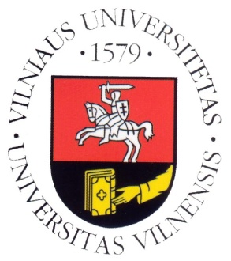
VILNIUS UNIVERSITY
FACULTY OF PHILOLOGY
DEPARTMENT OF TRANSLATION AND INTERPRETING STUDIES

MOCK CONFERENCE

PRESIDING OVER THE EU:
LESSONS TO BE LEARNED FROM LITHUANIA'S PREDECESSORS

22 February 2012
Room V2

AGENDA

Chair: Sally McDonald
14.00–14.05 Adoption of agenda
14.05–14.15 Sally McDonald (EN)
14.15–14.25 Julija Lazauskaitė (DE)
Lessons to be learned from Germany and Austria
14.25–14.35 Andrius Šimašius (LT)
ES Tarybos šalių pirmininkių bendradarbiavimas: Europos atminties ir sąžinės platformos pavyzdys
14.35–15.00 Discussion
15.00–15.10 Lina Kazlauskienė (EN)
Polish Presidency of the EU: aims and consequences
15.10–15.20 Akvilė Ivanauskaitė (DE)
Die slowenische EU-Ratspräsidentschaft – ein Vorbild für Litauen?
15.20–16.00 Discussion

