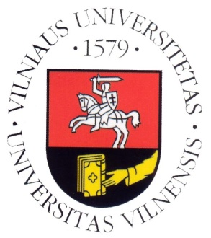
Vilnius University

Department of Translation and Interpreting Studies

SCIC Pedagogical Assistance

With Aušra Reklaitytė

Timetable for 29-31 October 2014

Wednesday, 29/10/2014

09:30–11:00 | FR (B)→LT, LT→FR 1st year (consecutive)
11:30–13:00 | FR (B)→LT, LT→FR 2nd year  FR (C)→LT
13:00–14:30 | Lunch break
14:30–16:00 | EN (B)→LT, LT→EN 1st year (consecutive)

Thursday, 30/10/2014

10:00–11:30 | EN (B)→LT, LT→EN 1st year (consecutive)
11:30–13:00 | Lunch break
13:00–14:30 | EN (B)→LT, LT→EN 2nd year  EN (C)→LT 2nd year
15:00–16:30 | DE (B)→LT, LT→DE 2nd year

Friday, 31/10/2014

10:00–11:30 | EN (B)→LT, LT→EN 2nd year  EN (C)→LT 2nd year
11:30–13:00 | Lunch break
13:00–15:00 | Mock conference (2nd year students, SIM)
15:15–16:00 | Feedback

