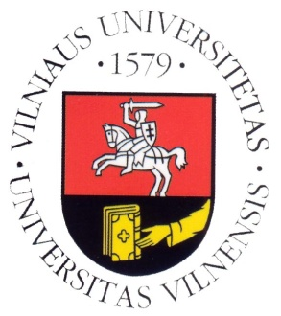
Vilnius University

Department of Translation and Interpreting Studies

SCIC Pedagogical Assistance

with Roderick Jones

Timetable for 23-25 February 2015

Monday, 23/02/2015

10:00–11:30 | Introduction into simultaneous interpreting 1st year  EN(B,C)>LT, LT>EN  FR(B,C)>LT, LT>FR  (Trainers: Eglė Žilinskaitė, Diana Guogienė)
11:30–13:00 | Lunch
13:00–14:30 | SIM, CONS 2nd year  EN(B,C)>LT, LT>EN  (Trainer: Diana Guogienė)
15:00–16:30 | SIM, CONS 2nd year  DE(B,C)>LT, LT>DE  (Trainer: Rasa Darbutaitė)

Tuesday, 24/02/2015

09:30–11:00 | SIM, CONS 2nd+1st year  FR(B,C)>LT, LT>FR  (Trainer: Eglė Žilinskaitė)
11:30–13:00 | SIM, CONS 2nd+1st year  FR(B,C)>LT, LT>FR  (Trainer: Eglė Žilinskaitė)
13:00–14:30 | Lunch
14:30–16:00 | SIM 2nd year  LT>DE  (Trainer: Rasa Darbutaitė)

Wednesday, 25/02/2015

10:00–11:30 | SIM, CONS 2nd year  EN(B,C)>LT, LT>EN  (Trainer: Diana Guogienė)
11:30–13:00 | Lunch
13:00–15:00 | Mock conference (SIM 1st and 2nd year)  (Trainers: Eglė Žilinskaitė, Diana Guogienė, Rasa Darbutaitė)
15:15–16:00 | Feedback

