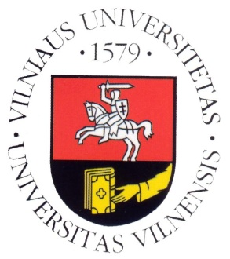
Vilnius University

Department of Translation and Interpreting Studies

SCIC Pedagogical Assistance

With Rachel Hayes

Timetable for 14-16 October 2013

Monday, 14/10/2013

10:00–11:30 | EN (B)→LT, LT→EN 2nd year  EN (C) →LT 2nd year
11:30–13:00 | Lunch break
13:00–14:30 | EN (B)→LT, LT→EN 1st year (consecutive)
15:00–16:30 | EN (B)→LT, LT→EN 1st year (consecutive)

Tuesday, 15/10/2013

10:00–11:30 | EN(B)→LT, LT→EN 2nd year  EN (C) →LT 2nd year
11:30–13:00 | Lunch break
13:00–14:30 | EN(B)→LT, LT→EN 2nd year  EN (C) →LT 2nd year
15:00–16:30 | EN (B)→LT, LT→EN 1st year (consecutive)

Wednesday, 16/10/2013

10:00–11:30 | FR (B)→LT, LT→FR 1st year (consecutive)
11:30–13:00 | Lunch break
13:00-15:00 | Mock conference (2nd year students, SIM)
15:15–16:00 | Feedback

