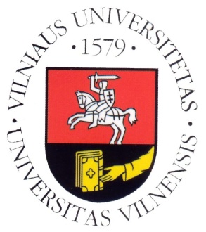
Vilnius University

Department of Translation and Interpreting Studies

SCIC Pedagogical Assistance

with Sophie Llewellyn Smith

Timetable for 24-26 November 2014

Monday, 24/11/2014

09:30–11:00 | LT→FR 1st year
11:30–13:00 | LT→FR 2nd year
13:00–14:30 | Lunch break
14:30–16:00 | EN(B)→LT, LT→EN 2nd year  EN(C)→LT 2nd year

Tuesday, 25/11/2014

09:30–11:00 | EN(B)→LT, LT→EN 1st year (consecutive)
11:30–13:00 | EN(B)→LT, LT→EN 2nd year  EN (C) →LT 2nd year
13:00–14:30 | Lunch break
14:30–16:00 | DE(B)→LT, LT→DE 2nd year  DE(C) →LT 2nd year

Wednesday, 26/11/2014

10:00–11:30 | EN (B)→LT, LT→EN 1st year (consecutive)
11:30–13:00 | Lunch break
13:00–15:00 | Mock conference (2nd year students, SIM)
15:15–16:00 | Feedback

