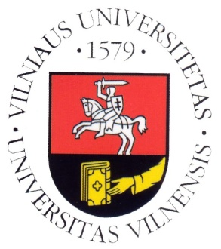
Vilnius University

Department of Translation and Interpreting Studies

SCIC Pedagogical Assistance

With Sally McDonald

Timetable for 20–22.02.2012

Monday, 20.02.2012

09:30–11:00 | FR(B)→LT→FR 2nd year  FR(C)→LT 2nd year
11:30–13:00 | FR(B)→LT→FR 2nd year  FR(C)→LT 2nd year
13:00–14:30 | Lunch
14:30–16:00 | EN(B)→LT→EN 1st year  EN(C)→LT 1st year
16:30–18:00 | EN(B)→LT→EN 1st year  EN(C)→LT 1st year

Tuesday, 21.02.2012

10:00–13:00 | Mock conference (con) + feedback  EN(B)→LT→EN 1st year  EN(C)→LT 1st year  IT (B)→LT →IT 1st year  IT (C)→LT 1st year  ES (C)→LT 1st year
13:00–14:30 | Lunch
14:30–16:00 | EN(B)→LT→EN 2nd year  EN(C)→LT 2nd year
16:30–18:00 | EN(B)→LT→EN 2nd year  EN(C)→LT 2nd year

Wednesday, 22.02.2012

09:30–11:00 | EN(B)→LT→EN 2nd year  EN(C)→LT 2nd year
11:30–13:00 | EN(B)→LT→EN 2nd year  EN(C)→LT 2nd year
13:00–14:30 | Lunch
14:00–16:00 | Mock conference (sim)  EN(B)→LT→EN 2nd year  EN(C)→LT 2nd year  DE(B)→LT→DE 2nd year  FR(B)→LT→FR 2nd year  FR(C)→LT 2nd year  IT (C)→LT 2nd year  ES (C)→LT 2nd year
16:00–16:30 | Feedback after the mock conference

