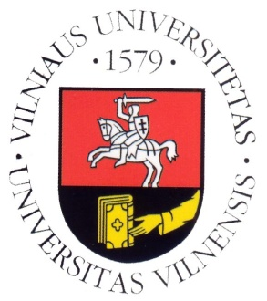
Vilnius University

Department of Translation and Interpreting Studies

SCIC Pedagogical Assistance

with Neil Munro

Timetable for 4–6 May 2015

Monday, 4/5/2015

10:00–11:30 | SIM, CONS 1st year  EN(B,C)>LT, LT>EN
11:30–13:00 | Lunch
13:00–14:30 | SIM, CONS 2nd year  EN(B,C)>LT, LT>EN
15:00–16:30 | SIM, CONS 2nd year  EN(B,C)>LT, LT>EN

Tuesday, 5/5/2015

09:30–11:00 | SIM, CONS 2nd year  FR(B,C)>LT, LT>FR
11:30–13:00 | SIM, CONS 2nd+1st year  FR(B,C)>LT, LT>FR
13:00–14:30 | Lunch
14:30–16:00 | SIM 2nd year  LT>DE

Wednesday, 6/5/2015

10:00–12:00 | SIM, CONS 1st year +2nd year  EN(B,C)>LT, LT>EN
12:00–13:10 | Lunch
13:10–15:00 | Mock conference (SIM 1st and 2nd year)
15:15–16:00 | Feedback

